**Controlling RGB LED Using PAN**

Project Submitted in Partial Fulfillment of the Requirements for the Degree of Bachelor of Technology in the field of Computer Science and Engineering

##### BY

Sayan Ghosh(123180703078)

Sourav Sahoo (123180703089)

Sankha Sarkar(380117011033)

Under the supervision

of

Sudipta Sahana

**

##### Department of Computer Science and Engineering

JIS College of Engineering

Block-A, Phase-III, Kalyani, Nadia, Pin-741235

West Bengal, India

May, 2020



**CERTIFICATE**

This is to certify that **Sayan Ghosh(123180703078),Sourav Sahoo(1231807089),Sankha Sarkar(380117011033)** has completed his/her project entitled **Controlling RGB Led using PAN,** under the guidance of  **Sudipta Sahana** in partial fulfillment of the requirements for the award of the **Bachelor of Technology in Computer Science and Engineering** from JIS college of Engineering (An Autonomous Institute)is an authentic record of their own work carried out during the academic year 2019-20 and to the best of our knowledge, this work has not been submitted elsewhere as part of the process of obtaining a degree, diploma, fellowship or any other similar title.

**--------------------------------- ------------------------------- ------------------------------**

**Signature of the Supervisor Signature of the HOD Signature of the Principal**

**_________________________________**

**Signature of the External Expert**

**Place:**

**Date:**



ACKNOWLEDGEMENT

The analysis of the project work wishes to express our gratitude to Guide Name for allowing the degree attitude and providing effective guidance in development of this project work. His conscription of the topic and all the helpful hints, he provided, contributed greatly to successful development of this work, without being pedagogic and overbearing influence.

We also express our sincere gratitude to Dr. Dharmpal Singh, Head of the Department of Computer Science and Engineering of JIS College of Engineering and all the respected faculty members of Department of CSE for giving the scope of successfully carrying out the project work.

Finally, we take this opportunity to thank Prof. **(Dr.) Partha Sarkar**, Principal of JIS College of Engineering for giving us the scope of carrying out the project work.

Date:

**…………………………………….………………………………….**

Sayan Ghosh

B.TECH in Computer Science and Engineering

6th/3rd

University Roll--123180703078

**…………………………………….………………………………….**

Sourav Sahoo

B.TECH in Computer Science and Engineering

6th/3rd

University Roll--123180703089

**…………………………………….………………………………….**

Sankha sarkar

B.TECH in Computer Science and Engineering

6th/3rd

University Roll--380117011033

**CONTENTS**

**Title page 1**

**Certificate 2**

**Acknowledgement 3**

**Introduction 5**

**Literature Survey 6-7**

**Problem Defination 7**

**Scope and Limitation 8**

**Motivations 8-9**

**Components Used 9-13**

**Methods and code 14-17**

**Circuit Diagram 18**

**Result and Discussion 19**

**Conclusion 20**

**INTRODUCTION**



This project is controlling RGB LED with Bluetooth that teaches how to control RGB LED wireless on your smartphone using bluetooth module, the possible purpose of this lesson is you can make an LED chaser using multiple colours respectively from the colour palette that you can control using this components.

Bluetooth technology is a high-speed low powered wireless technology link that is designed to connect phones or other portable equipment together. It is a specification (IEEE 802.15.1) for the use of low-power radio communications to link phones, computers, and other network devices over short distances without wires. Wireless signals transmitted with Bluetooth cover short distances, typically up to 30 feet (10 meters). It is achieved by embedded low-cost transceivers into the devices. It supports the frequency band of 2.45GHz and can support upto 721KBps along with three voice channels. This frequency band has been set aside by international agreement for the use of industrial, scientific, and medical devices (ISM).rd-compatible with 1.0 devices. It can connect up to “eight devices” simultaneously and each device offers a unique 48-bit address from the IEEE 802 standard with the connections being made a point to point or multipoint.

**LITERATURE SURVEY**

The Arduino Uno is a microcontroller board based on the ATmega328. It has 20 digital input/output pins (of which 6 can be used as PWM outputs and 6 can be used as analog inputs), a 16 MHz resonator, a USB connection, a power jack, an in-circuit system programming (ICSP) header, and a reset button. It contains everything needed to support the microcontroller; simply connect it to a computer with a USB cable or power it with a [AC-to-DC adapter](https://www.pololu.com/product/1463) or battery to get started.

The Uno differs from all preceding boards in that it does not use the FTDI USB-to-serial driver chip. Instead, it features an ATmega16U2 programmed as a USB-to-serial converter. This auxiliary microcontroller has its own USB bootloader, which allows advanced users to reprogram it.

The Arduino has a large [support community](http://arduino.cc/forum/) and an extensive set of support libraries and hardware add-on “[shields](https://www.pololu.com/category/113/shields-for-arduino)” (e.g. you can easily make your Arduino wireless with our [Wixel shield](https://www.pololu.com/product/2513)), making it a great introductory platform for embedded electronics. Note that we also offer a [SparkFun Inventor’s Kit](https://www.pololu.com/product/2776), which includes an Arduino Uno along with an assortment of components (e.g. breadboard, sensors, jumper wires, and LEDs) that make it possible to create a number of fun introductory projects.

This is the 3rd revision of the Uno (R3), which has a number of changes:

The USB controller chip changed from ATmega8U2 (8K flash) to ATmega16U2 (16K flash). This does not increase the flash or RAM available to sketches.

Three new pins were added, all of which are duplicates of previous pins. The I2C pins (A4, A5) have been also been brought out on the side of the board near AREF. There is a IOREF pin next to the reset pin, which is a duplicate of the 5V pin.

The reset button is now next to the USB connector, making it more accessible when a shield is used.

wireless communication is swiftly replacing the wired connection when it comes to the electronics and communication.The **HC-05** is a very cool module which can add two-way (full-duplex) wireless functionality. It uses the 2,4GHZ frequency band.The transfer rate of the data can vary up to 1Mbps and is in range of 10 meters.The HC-05 module can be operated by4-6V power supply You can use this module to communicate between two microcontrollers like Arduino or communicate with any device with Bluetooth functionality like a Phone or Laptop. It is a specification (IEEE 802.15.1) for the use of low-power radio communications to link phones, computers, and other network devices over short distances without wires. Wireless signals transmitted with Bluetooth cover short distances, typically up to 30 feet (10 meters). It is achieved by embedded low-cost transceivers into the devices. It supports the frequency band of 2.45GHz and can support upto 721KBps along with three voice channels. This frequency band has been set aside by international agreement for the use of industrial, scientific, and medical devices (ISM).rd-compatible with 1.0 devices.

**PROBLEM DEFINITION**

wireless communication is swiftly replacing the wired connection when it comes to the electronics and communication.By this circuit you can control the LED Lights or any kind of Lights we can control by our mobile wirelessly.However this modern type fecility we are want to use to make the life very simple.There are several types products and can be controlled by tour smart phone like fan tv light and many things.So in this project we are making a smart Led Control system using Arduino and Bluetooth module.The **HC-05** is a very cool module which can add two-way (full-duplex) wireless functionality. **Arduino Uno** is a microcontroller board based on 8-bit ATmega328P microcontroller. Along with ATmega328P, it consists other components such as crystal oscillator, serial communication, voltage regulator, etc. to support the microcontroller. Arduino Uno has 14 digital input/output pins (out of which 6 can be used as PWM outputs), 6 analog input pins, a USB connection, A Power barrel jack, an ICSP header and a reset button. The 14 digital input/output pins can be used as input or output pins by using pinMode(), digitalRead() and digitalWrite() functions in arduino programming. E

**SCOPE AND LIMITATION**

This System is use in many Appliences now a days,By the help of that we are controlling the system by our smart phone and making our life so simple .in our project we are using Bluetooth Module.And obviously there was and limition in the blutooth system that we only can connect devices in between 10 meters range.And also its password protection is not much strong and for this anybody can interrupt and missuse your system.But as a substitute of Bluetooth system .we may also use wifi modulo that module gives us better security and better range.This System can be use in the Outdoor decoration light and stage lighting system and home decoraction lighting system . Display matrix. Recently, RGB color mixing technology can also be found in LCD backlighting and projectors.  
In this tutorial we will learn how the RGB LED works and how we can control RGB led using HC-05 bluetooth module, Arduino IDE and an Android application

**MOTIVATION**

wireless communication is swiftly replacing the wired connection when it comes to the electronics and communication.By this circuit you can control the LED Lights or any kind of Lights we can control by our mobile wirelessly.However this modern type fecility we are want to use to make the life very simple.There are several types products and can be controlled by tour smart phone like fan tv light and many things.Also we done some progects with Arduino Uno and different kind of module.And after a web searching and seeing many more reference we are think and make the mini module with the help of Arduino module and Bluetooth module .This module is controlled by the wirelessly using ower smart phones.in this century Also many more Smart Applience are present that we are controlling by our smart phone. Display matrix. Recently, RGB color mixing technology can also be found in LCD backlighting and projectors.  
In this tutorial we will learn how the RGB LED works and how we can control RGB led using HC-05 bluetooth module, Arduino IDE and an Android application

***COMPONENTS USED***

***Arduino uno:-*** **Arduino Uno** is a microcontroller board based on 8-bit ATmega328P microcontroller. Along with ATmega328P, it consists other components such as crystal oscillator, serial communication, voltage regulator, etc. to support the microcontroller. Arduino Uno has 14 digital input/output pins (out of which 6 can be used as PWM outputs), 6 analog input pins, a USB connection, A Power barrel jack, an ICSP header and a reset button. The 14 digital input/output pins can be used as input or output pins by using pinMode(), digitalRead() and digitalWrite() functions in arduino programming. Each pin operate at 5V and can provide or receive a maximum of 40mA current, and has an internal pull-up resistor of 20-50 KOhms which are disconnected by default.  Out of these 14 pins, some pins have specific functions as listed below:

* **Serial Pins 0 (Rx) and 1 (Tx):-** Rx and Tx pins are used to receive and transmit TTL serial data. They are connected with the corresponding ATmega328P USB to TTL serial chip.
* **External Interrupt Pins 2 and 3:** These pins can be configured to trigger an interrupt on a low value, a rising or falling edge, or a change in value.
* **PWM Pins 3, 5, 6, 9 and 11:** These pins provide an 8-bit PWM output by using analogWrite() function.
* **SPI Pins 10 (SS), 11 (MOSI), 12 (MISO) and 13 (SCK):** These pins are used for SPI communication.
* **In-built LED Pin 13:** This pin is connected with an built-in LED, when pin 13 is HIGH – LED is on and when pin 13 is LOW, its off.

Along with 14 Digital pins, there are 6 analog input pins, each of which provide 10 bits of resolution, i.e. 1024 different values. They measure from 0 to 5 volts but this limit can be increased by using AREF pin with analog Reference() function.

* Analog pin 4 (SDA) and pin 5 (SCA) also used for TWI communication using Wire library.

Arduino Uno has a couple of other pins as explained below:

* **AREF:** Used to provide reference voltage for analog inputs with analogReference() function.
* **Reset Pin:**Making this pin LOW, resets the microcontroller.
* Arduino can be used to communicate with a computer, another Arduino board or other microcontrollers. The ATmega328P microcontroller provides UART TTL (5V) serial communication which can be done using digital pin 0 (Rx) and digital pin 1 (Tx). An ATmega16U2 on the board channels this serial communication over USB and appears as a virtual com port to software on the computer. The ATmega16U2 firmware uses the standard USB COM drivers, and no external driver is needed. However, on Windows, a .inf file is required. The Arduino software includes a serial monitor which allows simple textual data to be sent to and from the Arduino board. There are two RX and TX LEDs on the arduino board which will flash when data is being transmitted via the USB-to-serial chip and USB connection to the computer (not for serial communication on pins 0 and 1). A SoftwareSerial library allows for serial communication on any of the Uno's digital pins. The ATmega328P also supports I2C (TWI) and SPI communication. The Arduino software includes a Wire library to simplify use of the I2C bus.

### ****Arduino Uno Technical Specifications****

|  |  |
| --- | --- |
| Microcontroller | [ATmega328P](https://components101.com/microcontrollers/atmega328p-pinout-features-datasheet) – 8 bit AVR family microcontroller |
| Operating Voltage | 5V |
| Recommended Input Voltage | 7-12V |
| Input Voltage Limits | 6-20V |
| Analog Input Pins | 6 (A0 – A5) |
| Digital I/O Pins | 14 (Out of which 6 provide PWM output) |
| DC Current on I/O Pins | 40 mA |
| DC Current on 3.3V Pin | 50 mA |
| Flash Memory | 32 KB (0.5 KB is used for Bootloader) |
| SRAM | 2 KB |
| EEPROM | 1 KB |
| Frequency (Clock Speed) | 16 MHz |

#### *HC-05 - Bluetooth Module:-*

The **HC-05** is a very cool module which can add two-way (full-duplex) wireless functionality to your projects. You can use this module to communicate between two microcontrollers like Arduino or communicate with any device with Bluetooth functionality like a Phone or Laptop. There are many android applications that are already available which makes this process a lot easier. The module communicates with the help of USART at 9600 baud rate hence it is easy to interface with any microcontroller that supports USART. We can also configure the default values of the module by using the command mode. So if you looking for a Wireless module that could transfer data from your computer or mobile phone to microcontroller or vice versa then this module might be the right choice for you. However do not expect this module to transfer multimedia like photos or songs; you might have to look into the CSR8645 module for that.

The **HC-05** has two operating modes, one is the Data mode in which it can send and receive data from other Bluetooth devices and the other is the AT Command mode where the default device settings can be changed. We can operate the device in either of these two modes by using the key pin as explained in the pin description.

It is very easy to pair the HC-05 module with microcontrollers because it operates using the Serial Port Protocol (SPP). Simply power the module with +5V and connect the Rx pin of the module to the Tx of MCU and Tx pin of module to Rx of MCU as shown in the figure below

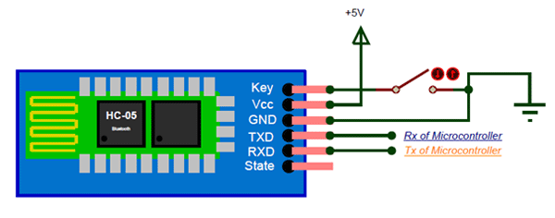

Fig-01

During power up the key pin can be grounded to enter into Command mode, if left free it will by default enter into the data mode. As soon as the module is powered you should be able to discover the Bluetooth device as “HC-05” then connect with it using the default password 1234 and start communicating with it. The name password and other default parameters can be changed by entering into the softwer.

### ****Pin Configuration****

|  |  |  |
| --- | --- | --- |
| **Pin Number** | **Pin Name** | **Description** |
| 1 | Enable / Key | This pin is used to toggle between Data Mode (set low) and AT command mode (set high). By default it is in Data mode |
| 2 | Vcc | Powers the module. Connect to +5V Supply voltage |
| 3 | Ground | Ground pin of module, connect to system ground. |
| 4 | TX – Transmitter | Transmits Serial Data. Everything received via Bluetooth will be given out by this pin as serial data. |
| 5 | RX – Receiver | Receive Serial Data. Every serial data given to this pin will be broadcasted via Bluetooth |
| 6 | State | The state pin is connected to on board LED, it can be used as a feedback to check if Bluetooth is working properly. |
| 7 | LED | Indicates the status of Module   * Blink once in 2 sec: Module has entered Command Mode * Repeated Blinking: Waiting for connection in Data Mode * Blink twice in 1 sec: Connection successful in Data Mode |
| 8 | Button | Used to control the Key/Enable pin to toggle between Data and command Mode |
|  |  |  |

**Jumper wire:-** Jumper wires are simply wires that have connector pins at each end, allowing them to be used to connect two points to each other without soldering. Jumper wires are typically used with [breadboards](https://blog.sparkfuneducation.com/what-is-a-breadboard) and other prototyping tools in order to make it easy to change a circuit as needed. Fairly simple. In fact, it doesn’t get much more basic than jumper wires.

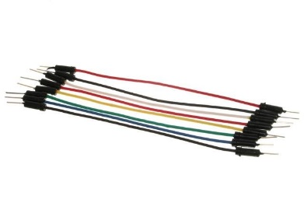

Fig-02

Though jumper wires come in a variety of colors, the colors don’t actually mean anything. This means that a red jumper wire is technically the same as a black one. But the colors can be used to your advantage in order to differentiate between types of connections, such as ground or power.

**METHODS AND CODE USED**

## Step 1: Connecting HC-05 Bluetooth Module With Arduino

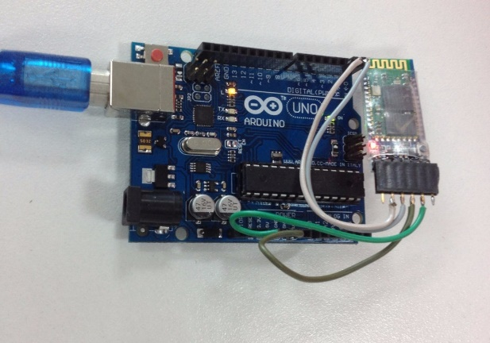

Fig-03

HC-05 is a serial port module which makes it very easy to use. If you see the pin configuration of HC-05, there are total 6 but we only need 4 middle ones for our set-up.

1. Connect VCC with 3.3V of Arduino, please do not connect it with 5V as that can cook the module
2. Connect GND with any GND of Arduino
3. Connect Rx pin with Tx of Arduino
4. Connect Tx pin with Rx of Arduino

Now power-up the Uno using USB cable, a red light LED on HC-05 will start blinking, means we are ready to go forward to the next step!

## Step 2: Connect the LED and Control It Using Arduino Serial Monitor

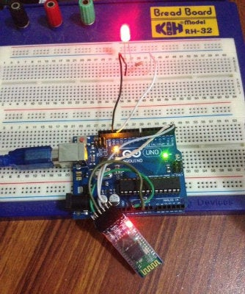

Fig-04

1. Connect the long end of LED with 220 ohm to 1K ohm resistor
2. Connect the other end of resistor to the pin 13 of Arduino
3. Connect the short leg of LED to GND of Arduino

If you prefer, you can skip this step and just use the built-in yellow LED of Arduino. Our circuit is now complete and we will now move forward to building our software blocks!.

Step3: Upload the following code to the Arduino using USB cable.

#include <SoftwareSerial.h>

SoftwareSerial BLU(0,1);

#define redPin 6

#define greenPin 3

#define bluePin 5

void setup()

{

//Serial setup

Serial.begin(9600);

Serial.println("-= HC-05 Bluetooth RGB

LED =-");

BLU.begin(9600);

BLU.println("-= HC-05 Bluetooth RGB LED

=-");

pinMode(4, OUTPUT);

digitalWrite(4,HIGH); pinMode(redPin, OUTPUT);

pinMode(greenPin, OUTPUT);

pinMode(bluePin, OUTPUT);

setColor(255, 0, 0);

delay(500);

setColor(0, 255, 0);

delay(500);

setColor(0, 0, 255);

delay(500);

setColor(255, 255, 255);

}

void loop()

{

while (BLU.available() > 0)

{

int redInt = BLU.parseInt();

int greenInt = BLU.parseInt();

int blueInt = BLU.parseInt();

redInt = constrain(redInt, 0, 255);

greenInt = constrain(greenInt, 0, 255); blueInt = constrain(blueInt, 0, 255);

if (BLU.available() > 0)

{

setColor(redInt, greenInt, blueInt);

Serial.print("Red: ");

Serial.print(redInt);

Serial.print(" Green: ");

Serial.print(greenInt);

Serial.print(" Blue: ");

Serial.print(blueInt);

Serial.println();

BLU.flush();

}

}

}

void setColor(int red, int green, int blue)

{

analogWrite(redPin, red);

analogWrite(greenPin, green);

analogWrite(bluePin, blue);

}

After uploading, open Arduino Serial Monitor, set the baud rate to 9600 and command line ending drop down (the one next to baud rate) to "No line ending", that means we will not be sending and /r or /n characters with our serial command.

Now type character "a" in the serial monitor and press send, the your LED should turn on, then send "b", the LED should turn off.

I have also attached the sketch file with this step, this is all we need at Arduino sketch level for turning LED on/off even through the Bluetooth and mobile app. In next step, we will communicate via bluetooth in order to play with our LED.

## Step 4: Getting HC-5 to Work With Arduino and Testing the Commuincation

In this step, we are focusing on getting HC-05 to work with Arduino and testing all the communication before we move towards building our mobile app.

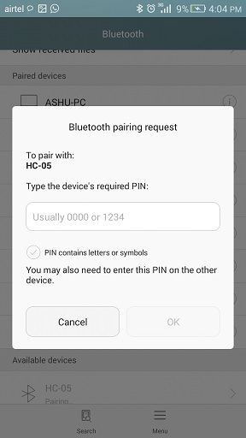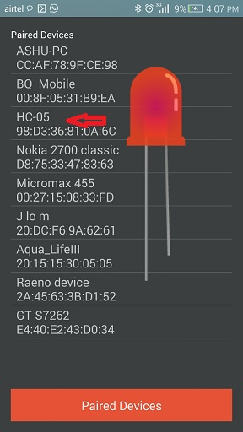

Fig-05

**CIRCUIT DIAGRAM**

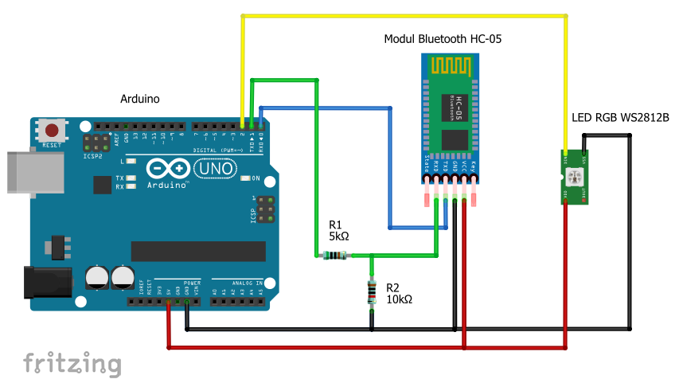

Fig-06

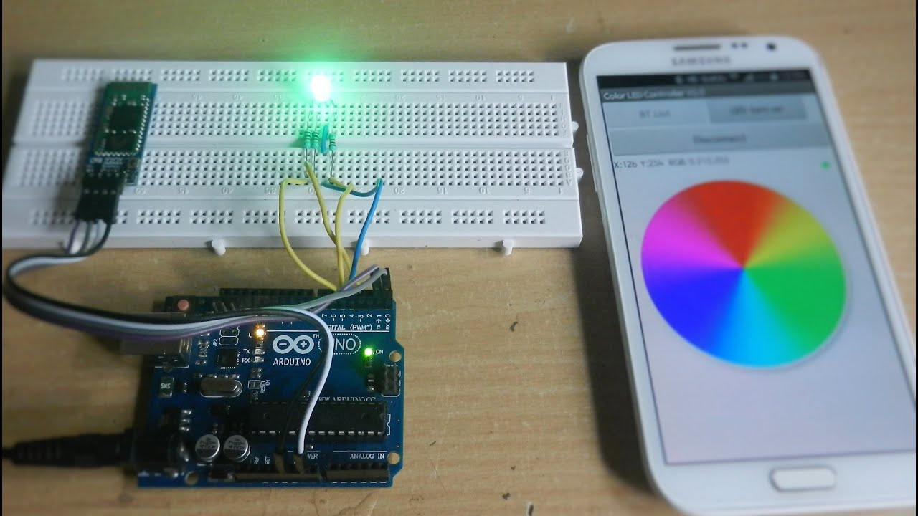

Fig-07

**RESULT AND DISCUSSION**

The aim objective of this project was to design and implement a simple wireless system. The mentioned system can to control the Led or anyother RGB Light product.By the helpof the softwear We can control the Led And also we can make any custom colour for the Led. With the help of this e can make a large projetcs and that can be used in the Stages ,outdoor lighting,and many more occations. Running all three colors at full brightness (0% duty cycles) made the LED painfully bright, but it did demonstrate that it can create white light. I wanted to make the LED display any color I wanted, but at a consistent, viewable brightness. To make the brightness consistent regardless of the color being generated, I needed to have the same total amount of power supplied to the three colors in the LED even as the as the color ratios changed. we found that the best way for me to think about power was in terms of a value out of 255. Then, I need to pick a sum of duty cycles, shared by the three colors. For example, if I made the sum of the duty cycles 100 (out of 255), and wanted a white light, I would set each color to 33. This would be the same brightness as if I set the red to 100 and the other two to 0, or made yellow with 50 red, 50 green, and 0 blue.Ultimately we found that a total out of 30 made for the best viewing brightness.

**CONCLUSION**

The Aim of doing this projects to design and implement the smart wireless control system.Smart bulbs have been recently increasing in popularity and are steadily becoming a key part of the smart home toolkit. Smart bulbs enable the user to control their light via a special application on the user’s smartphone. The bulb can be turned on and off and the color can be changed from the application interface. In this article, we will describe a project implementing a smart bulb controller that can be controlled from a manual button or a mobile application via Bluetooth. To add some flair to this project we have added some features which allow the user to choose a lighting color from the list of colors included in the application interface. It can also activate an “auto mix” to generate color effects and change the lighting every half second. The user can create their color mix using a PWM feature which can also be used as a dimmer for the three basic colors (red, green, blue). the possible purpose of this lesson is you can make an LED chaser using multiple colours respectively from the colour palette that you can control using this components. Bluetooth technology is a high-speed low powered wireless technology link that is designed to connect phones or other portable equipment together. It is a specification for the use of low-power radio communications to link phones, computers, and other network devices over short distances without wires. Wireless signals transmitted with Bluetooth cover short distances.And this wireless technology will grows day by day.Thousands of products we are controlling wirelessly and make our life simple and happy.